**Business Requirements Document**

**Project: Zealand Immigration Website and Integration**

**By: Sammy John Rawlinson**

**1 Problem Overview**

1.1 Introduction

1.2 Statement of Problem or Need

Zealand Immigration Services faces several challenges in managing its operations and client interactions efficiently. The current system lacks integration between offline methods and the existing Customer Relationship Management (CRM) system, resulting in inefficiencies and potential data inconsistencies. Additionally, the website, which is a critical component for client engagement, is developed, managed, and maintained by an external developer agency, leading to dependencies that may hinder timely updates and improvements.

The organization requires a comprehensive solution that streamlines operations, ensures seamless data integration across all platforms, and enhances client communication channels. This solution should also facilitate better internal coordination among various departments and improve the overall client experience by leveraging modern technologies and best practices.

By addressing these needs, Zealand Immigration Services aims to enhance its operational efficiency, reduce dependencies on external entities, and provide a superior service experience to both individual and business clients.

1.3 Description of Current System

1.3.1 Business Context Diagram

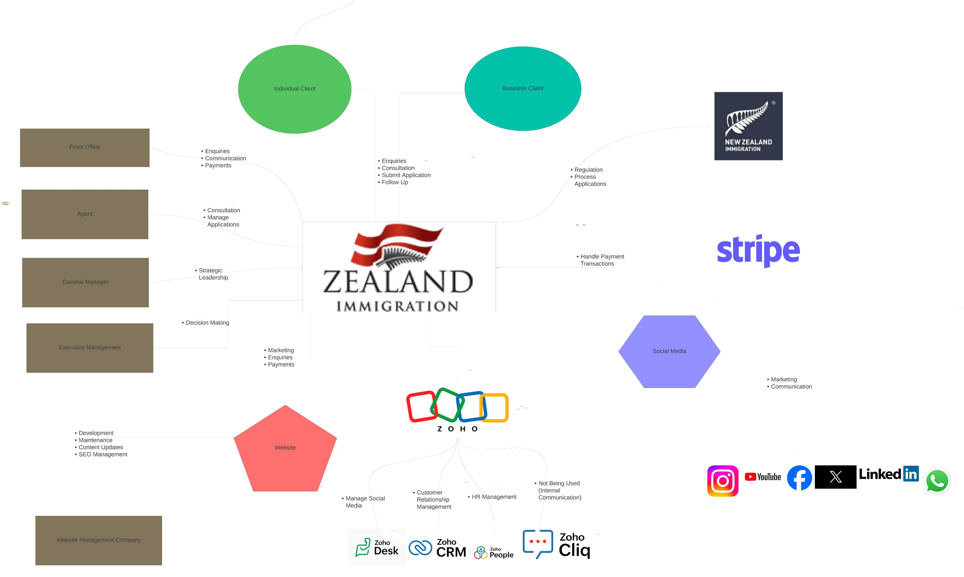

The key external entitiies it deals with are:

* **Immigration New Zealand** that sets visa requirements and processes visa applications.
* **Customers** using the service to apply for visas.
* **Website Development Company** that builds, manages and maintains the website
* **Zoho CRM** external software that manages Customer Relationship Management
* **Stripe** 3rd party online payment company

1.3.2 Current System Context Diagram

Current website and integration interaction .

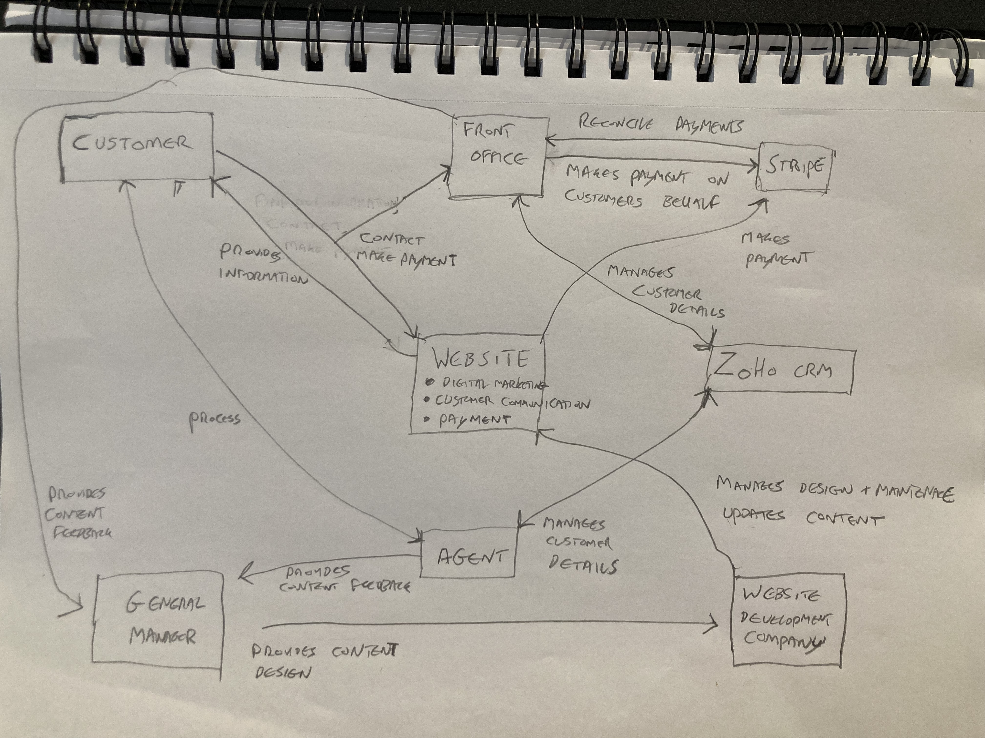

1.3.3 Current Business Processes

List of current processeses for the website.

* **Provide Information:** Customer visits the site to look for visa information and agency to help with their visa application process.
* **Contact:** Customer can complete various forms seeking consultation with agents, request more information, updates on current process status.
* **Make Payment:** Customer makes payment via Stripe
* **Digital Marketing:** SEO pushes awareness and better search results for greater exposure to potential customers.

1.3.4 Activity Sequence Diagram for current business processes  
  
**Customer Journey:** Interaction with website and Zealand Immigration currently.

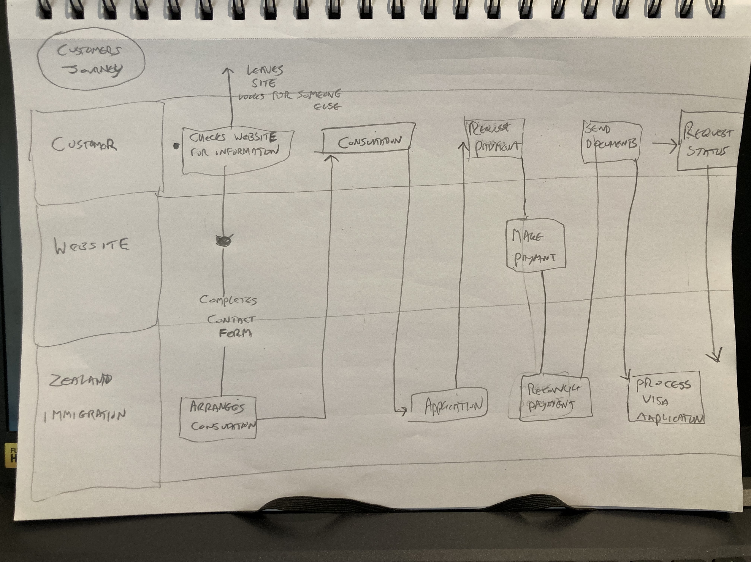

Functional flow diagram for process of Customer Relationship Management during their useof service.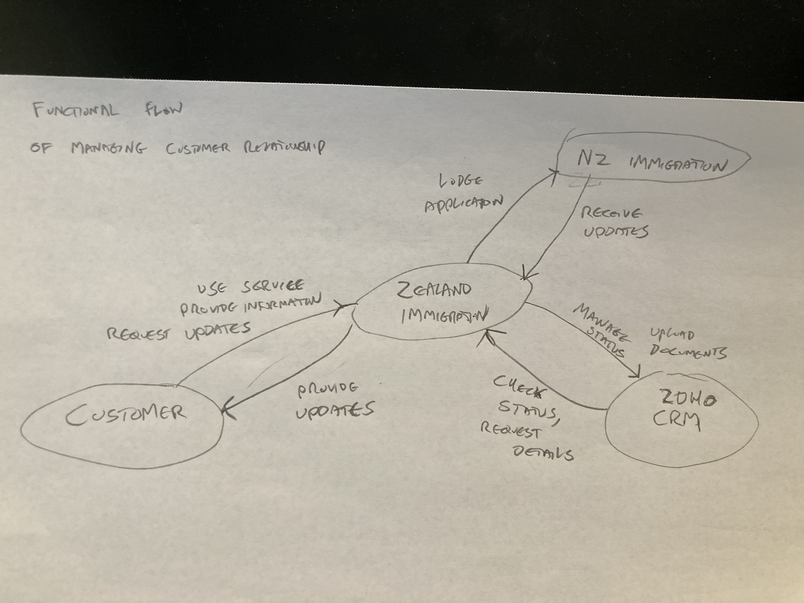

**2 Business Requirements**

2.1 Business Requirements

2.1.1 List of Stakeholders for the Website

* **Indiviudal Clients:** Users seeking advice and assistance on visa applications.
* **Business Clients:** Companies seeking advice and assistance on visa applications for potential employees.
* **Front Office Staff:** Handling interactions with clients, processing payments and providing information.
* **Agents:** Consulting potential clients, processing applications and customer support. Providing direction for content of the site based on client feedback and requests.
* **General Manager:** Manage digital marketing strategy, making sure the website provides a good user experience and is generating traffic by providing relevant content.
* **Zoho CRM:** Manages Customer Relationship Management.
* **Stripe:** Payment gateway for handling customer payments.

**Indirect Stakeholders**

* **Owners/Executive Management:** Key decision makers influencing stategic direction and resource allocation.
* **New Zealand Immigration:** Government agency that processes visa applications and sets legal compliance standards.

2.1.2 List of Business requirements

A website redesign should incorporate the following requirements:

* Ensure the website is optimized for mobile devices first, providing a seamless experience across all screen sizes.
* Create an intuitive and visually appealing user interface (UI) that enhances the overall user experience (UX).
* Implement straightforward navigation to facilitate a positive user journey, enabling users to easily find relevant information.
* Ensure content is organized and accessible, allowing users to quickly locate information that is pertinent to their needs.
* Automate and streamline the contact process to minimize manual input and facilitate efficient communication.
* Enhance SEO capabilities through effective CMS management to increase website visibility and traffic.
* Simplify the payment process to facilitate easier manual reconciliation, clearly identifying who has paid and when.
* Integrate the subscription process with Zoho CRM for efficient mailing list management and automated communication.
* Provide users with more contact options, improving communication channels to request and provide information such as status updates or documentation.
* Ensure the website has strong security measures and privacy protocols to protect user data and comply with regulatory standards.
* Optimize website performance for fast loading times and smooth operation, even during peak usage.
* Offer content in multiple languages to cater to a diverse user base and improve accessibility for non-English speakers.
* Ensure the website meets accessibility standards (e.g., WCAG) to provide a user-friendly experience for individuals with disabilities.
* Integrate robust analytics and reporting tools to track website performance, user behavior, and key metrics for continuous improvement.

2.1.3 Project Scope

First Iteration:

* Feedback and Suggestions:
  + Provide feedback and suggestions to the General Manager on adapting the current website and the ongoing redesign plans.
  + Evaluate and provide feedback to the General Manager on the implementation by external developers regarding the new website design and functionality.

Second Iteration:

* Prototype Development:
  + Develop a prototype alternative design to improve upon the new website design.
* Assessment and Analysis:
  + Assess the pros and cons of:
    - Keeping the new design with suggested improvements.
    - Investigating alternative architectures for the website that meet the requirements.
    - Exploring out-of-the-box solutions as potential alternatives.
    - Adopting the alternative design.
* Reporting:
  + Provide a comprehensive report to the business, detailing the findings and recommendations to facilitate informed decision-making.
* Vision Document:
  + Create a vision document outlining the long-term strategy for the website.

Third Iteration:

* Future Functionality:
  + Investigate the addition of new and future functionalities, such as implementing AI for enhanced user interaction.
* Implementation Assistance:
  + Support the implementation of decisions made through:
    - Continued feedback and suggestions if maintaining the current system.
    - New design and implementation for a custom-built solution.
    - New design and implementation if opting for an out-of-the-box solution.

2.2 Description of Future State

2.2.1 Future state system context diagram

Acitvity sequence diagram for future **Customer Journey**

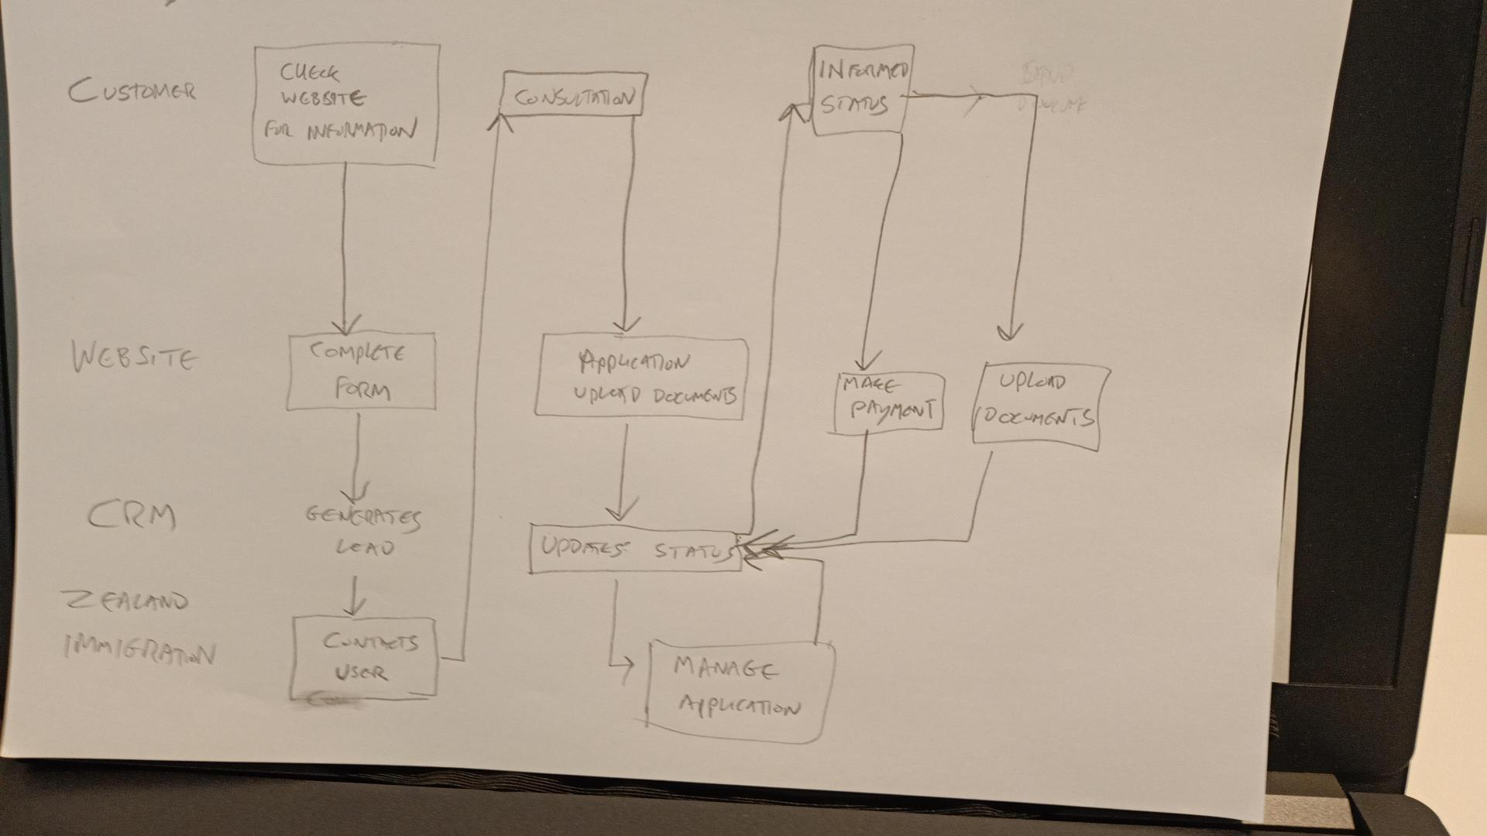

By integrating the website more with the CRM and automating communication processes it significantly cuts down on interaction between the client and organisation reducing time front office and agents need to manually contact the client. It streamlines the information at a faster and scheduled rate, improving efficiency and experience.

Activity sequence diagram for future **Content Management** of the site.

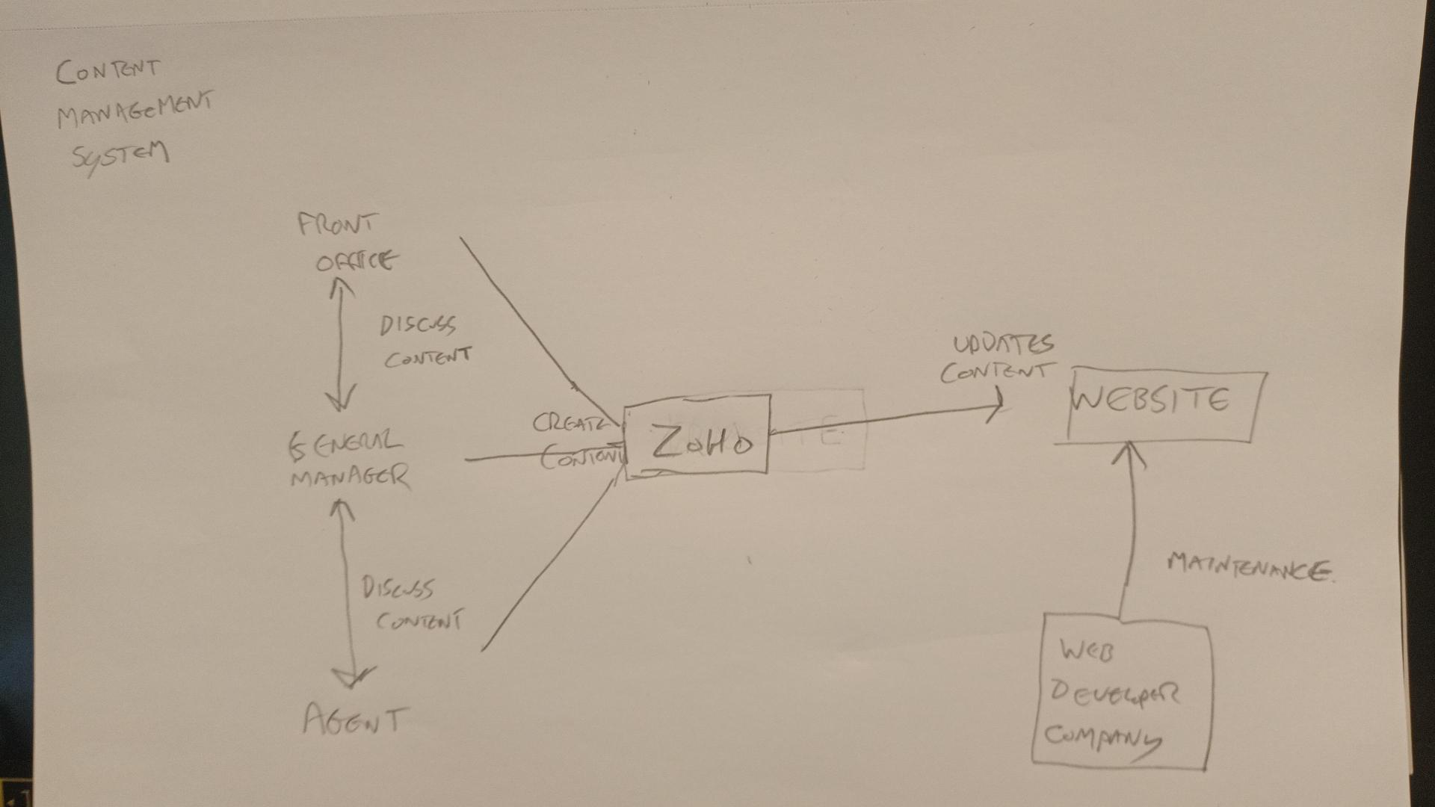

By utilising the current internal system Zoho’s various apps the internal team should be able to manually create content for the site (whether ut be certain articles of information) or via creating posts. This makes content updating more efficient and prevalent with out having to rely on external partners. This helps digital marketing in two ways:

* More control of content keeping the user informed with up to date information.
* More control of SEO by managing the content accordingly based on metrics and user feedback analytics, being more relevant.

**3 Business Solution**

3.1 Options Considered

3.1.1 Options

* Option 1: Current Website redesign continues
* Option 2: Assess other system architecture frameworks to custom build solution
* Option 3: Assess packaged out-of-the-box solutions

3.1.2 Evaluation Criteria

* Cost
* Timeliness
* Development Team Skillset with proposed system architetures
* Suitability of system for requirements
* Maintenance requirements of system
* Ease of use for inhouse team.

3.1.3 Evaluation

|  |  |  |  |
| --- | --- | --- | --- |
| Evaluation Criteria | Option 1: Current | Option 2: Custom | Option 3: Packaged |
| Cost | High | Medium | Low |
| Timelines | Quick | Late | Medium |
| Developer Skillset | High | Medium | Low |
| Suitability | Low | High | Medium |
| Maintenance | Medium | High | Low |
| Ease of Use | Low | High | Medium |
| Overall Ranking | 1 | 2 | 3 |

In the scope of the project timeframe to develop a solution suitable the current system re-design utilizing the current architecture and refined feature requirements will be best solution.

3.2 Recommended Solution

3.2.1 Business Solution Outline

The current re-design of the website by General Manager and Outside development team built on Shopify (Ruby on Rails, Liquid, GraphSQL) will create a more responsive and better user experience. The CMS capability has been discussed and can be implemented. There needs to be further exploration into integration with Zoho CRM and further definition of automative steps that would be managed by the external developers to create a solution and would fall outside of the scope of this project.

3.2.2 Main Features

* More responsive website
* Better navigation user experience
* Implemented CMS capability for in house team

3.2.3 Unique Value Proposition / Justification

* Utilizes pre-packaged solutions in creating Responsive design and user experience
* Maintains preferred ongoing relationship with current developers
* Allow future customization and changes to UI design
* Maintenance support for CMS facilities should the future state of operations change
* No need for inhouse skill development or hiring to manage marketing
* Current requirements for integration capability can be met.